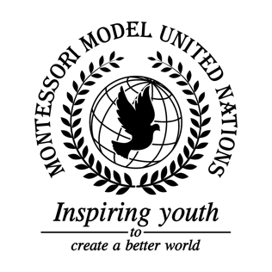

Resolution United Nations Human Rights Council/2.1

United Nations Human Rights Council
Co-sponsors: Republic of Albania, Antigua and Barbuda, Commonwealth of Australia, Belize, Kingdom of Denmark, Dominican Republic, Republic of Estonia, Republic of Fiji, Hellenic Republic, Republic of Guatemala, Republic of Guinea, Republic of Iraq, Republic of Italy, State of Kuwait, Kingdom of Lesotho, Islamic Republic of Mauritania, Mongolia, Federal Republic of Nigeria, Democratic People's Republic of Korea, Republic of Senegal, Federal Republic of Somalia
Topic: The Situation in Yemen
The Committee,

Alarmed by the amount of violence in Yemen,
Deeply concerned that the Yemeni people can't receive the food and medical supplies that they need,
Taking into consideration that the prices have sky-rocketed leading to mass depletion of supplies,
Recognizing the abusive behavior from all involved parties towards children,
Fully alarmed that Yemen might be the first country to run out of water,
Deeply disturbed that the war conflict in Yemen is affecting other countries as well,
Noting with deep concern that people are not getting immunized along with citizens dying of famine and cholera,
- Expresses its hope to take down the Yemen blockade;
- Considers sending a voluntary diplomat to areas in need;
- Encourages countries to stop sending weapons to all parties involved;
- Further invites involved member states to a summit to discuss the importance of peace relations;
- Supports an election for new government officials;
- Calls for more refugee camps;
- Encourages donations and/or funding to help the citizens of Yemen;
- Calls upon the UN to try to recommend all involved parties to stop all conflict;
- Draws the attention of what the landmines might and will cause, and asks that the UN sends more landmine detectors to Yemen;
- 10.Requests that the UN repairs and rebuilds hospitals, schools and businesses;
- Supports the idea of air-dropping medical supplies, food, and water;
- Further requests that healthcare specialists should be temporarily transferred gravely effected areas of Yemen.

