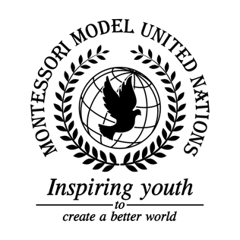

Resolution United Nations Human Rights Council/1.1

United Nations Human Rights Council
Co-sponsors: Republic of Albania, Antigua and Barbuda, Commonwealth of Australia, Belize, Kingdom of Denmark, Dominican Republic, Republic of Estonia, Republic of Fiji, Hellenic Republic, Republic of Guatemala, Republic of Guinea, Republic of Iraq, Republic of Italy, State of Kuwait, Kingdom of Lesotho, Islamic Republic of Mauritania, Mongolia, Federal Republic of Nigeria, Democratic People's Republic of Korea, Republic of Senegal, Federal Republic of Somalia
Topic: The Safety of Journalists
The Committee,

Deeply Concerned about the number of Journalists that have been harmed over the past 28 years,
Alarmed by the fact that Journalist's basic human rights have been violated,
Deeply disturbed by the lack of journalist's protection and safety,
- Requests that a bodyguard should accompany journalists if they desire during many dangerous assignments;
- Encourages journalists to undergo self-defense training;
- Further recommends journalist safety websites consisting of the whereabouts of their next assignments and the danger level;
- Encourages journalists to be armed with a small weapon, if necessary;
- Emphasizes the importance of a safehouses equipped with defenses in unsafe countries for every journalist;
- Requests that the police and the government shall not neglect a journalist who is asking for help;
- Approves of journalists being equipped with bulletproof vests in high conflict areas;
- Supports journalists traveling in pairs;
- Further reminds countries to raise awareness;
- Authorizes the formation of a world court branch on the matter of the safety of journalists.

