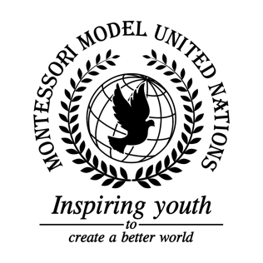

Resolution United Nations Human Rights Council/1.2

United Nations Human Rights Council
Co-sponsors: Republic of Maldives, Japan, Republic of Austria, Republic of Finland, Kingdom of Cambodia, Kingdom of Bahrain, Republic of the Union of Myanmar, Republic of Costa Rica, Republic of Ecuador, Plurinational State of Bolivia, Republic of Rwanda, Republic of Bulgaria, Gabonese Republic, Republic of Seychelles
Topic: The Safety of Journalists
The Committee,

Recalling resolution 1738 made in 2006, which states that journalists in war zones are considered citizens and should be treated as such,
Noting with satisfaction that the UN has devoted many days to protecting journalists,
Recalling the UN plan of action on the Safety of Journalists and the Issue of Impunity: consultation outcome document, August 16th 2017,
Expressing satisfaction to UNESCO for creating the project: training security forces on the freedom of expression,
Approving that the UN should inform the public in order to protect journalists,
- Encourages that no location services should be on while using public social media;
- Recommends that journalist headquarters should be created;
- Calls upon a safe form of government transportation that the journalist’s institution pays 50% of the cost;
- Requests a 40% reduced cost for health and life insurance that is paid for by the government for journalists;
- Encourages the support for Sustainable Development Goal 16 Target 10;
- Considers that journalists host a discussion or meeting to share their knowledge and findings internationally.

