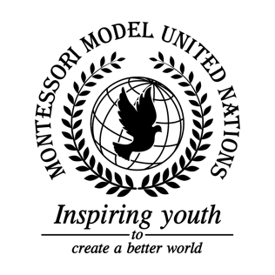

Resolution Food and Agriculture Organization of the United Nations/1.1

Food and Agriculture Organization of the United Nations
Co-sponsors: Republic of Angola, Republic of Austria, Belize, Burkina Faso, Republic of Chile, People’s Republic of China, Democratic Republic of the Congo, Republic of Croatia, Kingdom of Denmark, Republic of Ecuador, Republic of Equatorial Guinea, Republic of Estonia, Federal, Republic of Germany, Republic of Guatemala, Republic of Honduras, Hungary, Republic of India, Republic of Iraq, Republic of Kazakhstan, Lao People’s Democratic Republic, The former Yugoslav Republic of Macedonia, Republic of Maldives, United Mexican States, Republic of, Moldova, Mongolia, Federal Democratic Republic of Nepal, New Zealand, Islamic Republic of, Pakistan, Republic of the Philippines, Independent State of Samoa, Republic of Serbia
Topic: Combating Illegal, Unreported and Unregulated (IUU) Fishing
The Committee,

Recognizing that although punishment is necessary for illegal, unreported and unregulated (IUU) fishing, it must be dealt with in a peaceful way, such as fines or community service,
Believing citizens who are affected by IUU fishing must be educated on the effects and laws relating to IUU fishing and similar issues,
Fully aware that security is an important part of preventing IUU fishing,
Reminding that illegal fishing impacts the economy through loss of taxes, jobs, and food,
Deeply concerned that slaves have been working up to 24 hours a day fishing illegally,

- Encourages all countries to sign documents such as the PSMA, PA, and the CTA;
- Recommends that there is a limit put on the number of fish permitted to be caught;
- Requests a limit on the number of Flags of Convenience that can be sold;
- Calls upon countries to ensure they have regulations that monitor and enforce the fishing standards of sustainability;
- Expresses its appreciation of the importance of IMO and UVI identification numbers on every fishing vessel;
- Further requests that member states ban large fishing nets that destroy marine biomes and ecosystems;
- Encourages that attention be paid to training coast guards to check boats and their crews when they dock;
- Recommends tracking fishing materials in case they pollute and destroy habitats in water;
- Encourages all UN member states to create more fish farms and promote agriculture;
- Further invites countries to upgrade water security with long distance drones for surveillance;
- Strongly approves the creation of a free smartphone app that can be used to make sure fish are caught legally and report illegal fishers.

