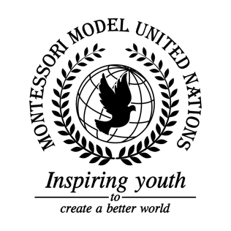

Resolution Food and Agriculture Organization of the United Nations/2.1

Food and Agriculture Organization of the United Nations
Co-sponsors: Commonwealth of Australia, Republic of Botswana, Federative Republic of Brazil, Republic of Bulgaria, Kingdom of Cambodia, Canada, Republic of Chad, Republic of Costa Rica, Republic of Côte d’Ivoire, Dominican Republic, Arab Republic of Egypt, Republic of Fiji, Republic of France, Georgia, Republic of Ghana, Grenada, Islamic, Republic of Iran, Republic of Italy, Republic of Kenya, Kyrgyz Republic , Libya, Republic of Nauru, Kingdom of the Netherlands, Sultanate of Oman, Russian Federation, Republic of Slovenia
Topic: The State of Food Security and Nutrition in the World
The Committee,

Noting with regret that war causes many food insecurities,
Keeping in mind that the majority of starving people are poor and/or homeless,
Alarmed by the rate at which climate change crops,
Having studied that some common and/or cheap desirable foods are unhealthy,
Recalling that knowledge of basic nutrition is essential,
Deeply disturbed by the fact that healthy food is wasted,
Drawing attention to how poverty affects the people’s lives,
Urges people to be aware of the effects of climate change,

- Encourages countries to improve farm training;
- Further requests countries to build more green houses;
- Recommends spending 0.2-0.3% of GDP on studying the cross-breeding of crops for drought resistance;
- Expresses its hope for more community gardens;
- Calls upon all countries to sign the Paris Agreement;
- Requesting that most factories install solar panels;
- Emphasizes the need for countries to create a compost program where all food scraps are made into compost to grow crops;
- Suggests that the whole month of August is World Food Month;
- Approves selling food in smaller portions to reduce waste;
- Supports countries’ education on nutritious diets;
- Strongly recommending countries to put stricter regulations on the use of food chemicals;
- Authorizes exporting nutritious food to developing countries.

