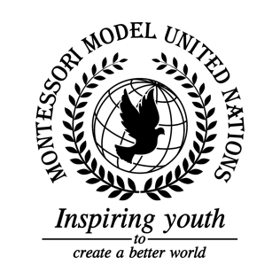

Resolution Food and Agriculture Organization of the United Nations/1.1

Food and Agriculture Organization of the United Nations
Co-sponsors: Commonwealth of Australia, Republic of Botswana, Federative Republic of Brazil, Republic of Bulgaria, Kingdom of Cambodia, Canada, Republic of Chad, Republic of Costa Rica, Republic of Côte d’Ivoire, Dominican Republic, Arab Republic of Egypt, Republic of Fiji, Republic of France, Georgia, Republic of Ghana, Grenada, Islamic, Republic of Iran, Republic of Italy, Republic of Kenya, Kyrgyz Republic , Libya, Republic of Nauru, Kingdom of the Netherlands, Sultanate of Oman, Russian Federation, Republic of Slovenia
Topic: Combating Illegal, Unreported and Unregulated (IUU) Fishing
The Committee,

Deeply concerned about the economic and ecological issues IUU fishing presents,
Keeping in mind that the education and awareness are important so people can think before they act,
Alarmed by how taxing a troll net is on the ecosystems,
Bearing in mind that IUU fishing sometimes gets the government’s money,
Taking into consideration that it may take time to fix what has been done to the economy and the ecosystem,
- Emphasizes placing surveillance cameras on buoys (funds are by 0.5%-1% GDP per month until there is enough funding);
- Further inspecting before and after going out, showing their license at the dock;
- Urges countries to sign the Port State Measures Agreement;
- Suggests that countries restrict certain fishing areas so that fishermen can fish sustainably and legally;
- Further requests to review limits on how many fish a Vessel can harvest;
- Supports giving every ship an unchangeable identification number and flag;
- Requests that every load of fish must have a certificate so that countries can tell if the catch is legal;
- Encourages disguising Coast Guards as other fisherman;
- Recommends that there are more Coast Guards to patrol the waters for illegal fisherman;
- Urges limiting the amount of ships allowed on the water;
- Urges upon countries to create an international and up to date database for fishing vessels;
- Authorizes a profession for people to scuba dive and clean trash from the ocean;
- Encourages safety of fish populations, especially in remote bodies of water;
- Strongly recommends countries to stop producing plastic fishing tools and instead use biodegradable materials;
- Recommends a group of organizations which would regulate individual large bodies of water by tracking the water vessels as well as the catch of the water vessels.

