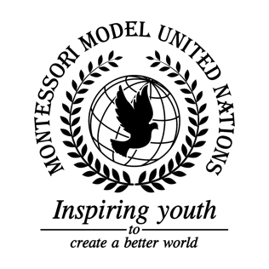

Resolution United Nations Office on Drugs and Crime/3.1

United Nations Office on Drugs and Crime
Co-sponsors: Kingdom of Belgium, Plurinational State of Bolivia, Bosnia and Herzegovina, Central African Republic, People’s Republic of China, Republic of Colombia, Arab Republic of Egypt, Republic of El Salvador, Federal Democratic Republic of Ethiopia, Republic of Fiji, Federal Republic of Germany, Islamic Republic of Iran, State of Israel, Japan, Republic of Lebanon, Republic of the Union of Myanmar
Topic: Bias and False News in the Media
The Committee,

Recognizes the harm caused by biased media,
Fully aware of the need for a credible global news network,
Aware that citizens are in need of better media education,
Alarmed by the spread of misinformation, disinformation, malinformation, biased propaganda, and biased media on the Internet,
Noting with regret the effect that false information has on victims,

- Expresses its hope for schools to create student run newspapers;
- Recommends citizens to trust only fact-based local sources;
- Encourages member states to inform citizens of new media platforms that provide more jobs;
- Calls upon journalists to create reliable global news articles;
- Further requests that member states educate citizens on the spread of false information on the Internet;
- Emphasizes the importance of critical thinking when presented with questionable information and information that might incite any unreasonable, harmful, or dangerous actions;
- Encourages the use of fact checkers and other such sources to verify the legitimacy of certain information, thus supporting the creation of better fact checking websites;
- Expresses its hope that people stand up for those who are targeted by biased media.

