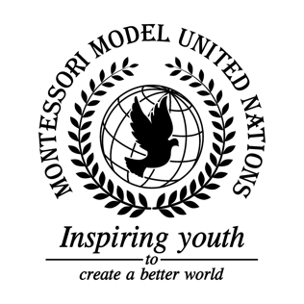

Resolution GA/3/4.1

General Assembly Third Committee
Co-sponsors: Republic of Armenia, Republic of Belarus, Republic of Cameroon, Republic of Cyprus, Czech Republic, Arab Republic of Egypt, Republic of Guinea-Bissau, Islamic Republic of Iran, Republic of Kazakhstan, Republic of Lebanon, Libya, Grand Duchy of Luxembourg, Federated States of Micronesia, Federal Democratic Republic of Nepal, New Zealand, Republic of the Philippines, United Kingdom of Great Britain and Northern Ireland
Topic: Homophobia amongst parents against gay teachers
The Committee,

Taking into consideration that one’s sexuality was discriminated against,
Deeply concerned that parents are influencing their children’s beliefs negatively,
Fully aware that there were witnesses that avoided the situation,
Realizing that the teacher put in his best efforts to help the child,
Deeply disturbed by the parents’ actions in front of children off school grounds,
Recognizing that cases like this occur all over the world,
Keeping in mind the point of view of both the parent and the teacher,
- Considers creating a helpline for individuals to reach out to when dealing with discrimination;
- Further expresses its hope that individuals will learn to express themselves through parades, holidays, and celebrations;
- Strongly considers having an international culture day;
- Supports the use of advertisements and commercials to educate people about the LGBTQ+ community;
- Suggests workshops be implemented in schools for both parents, teachers, and students on the topic of discrimination and respect;
- Recommends social media, news agencies, and social events be used to draw awareness to this issue;
- Authorizes a protocol to be made for schools on how to deal with situations like this;
- Strongly declares immature behavior for parents to not be tolerated by schools.

