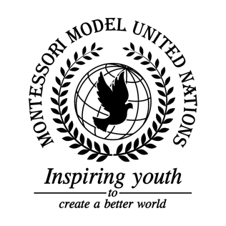

Resolution GA/3/2.1

General Assembly Third Committee
Co-sponsors: Republic of Armenia, Barbados, Republic of Belarus, Belize, Republic of Cameroon, Republic of Colombia, Republic of Cyprus, Czech Republic, Arab Republic of Egypt, Republic of Guinea-Bissau, Islamic Republic of Iran, Ireland, Republic of Kazakhstan, Republic of Latvia, Republic of Lebanon, Libya, Grand Duchy of Luxembourg, Federated States of Micronesia, Republic of Namibia, Federal Democratic Republic of Nepal, New Zealand, Republic of the Philippines, United Kingdom of Great Britain and Northern Ireland
Topic: Elimination of Racism, Racial Discrimination, Xenophobia and Related Intolerance
The Committee,

Fully aware that the rate of pregnancy related deaths for black women are 43 per 100,000 live births, versus 15 such deaths among white women,
Deeply conscious of the amount of hate organizations worldwide,
Alarmed by how there were 47,000 cases of racist incidents in England and Wales in 2013,
Bearing in mind that in 2016, there were 1,835 hate crimes reported in France,
Keeping in mind that 99.9% of human DNA is the same,
Noting with concern the amount of discrimination against indigenous people and refugees,
Deeply concerned by how racism, discrimination, xenophobia, and related intolerance has risen in the last decade,
Taking into account the 6,000 neo-Nazis in Germany reported in 2012,
Recognizing the amount of discrimination against immigrants and refugees internationally,

- Encourages that students be exposed to more cultures, ethnicities, and minority groups, as well as teaching them the history and definition of racism, xenophobia, and related intolerance, along with human rights, focusing more on similarities than differences;
- Expresses its hope that social media platforms will be more proactive in the removal of

hateful comments;
- Suggests prices and fares do not change based on race, religion, ethnicity, and sexual orientation;
- Recommends countries to come together to discuss the definition of racism, xenophobia, discrimination, and related intolerance, as well as protocols to take in response to hateful acts;
- Requests a flag be made to represent being human and equal;
- Further requests campaigns and events be hosted to remember the victims of hate crimes;
- Further suggests countries prohibit companies from rejecting individuals based on race, ethnicity, religion, or sexual orientation;
- Encourages countries to assist indigenous people to keep their land;
- Reminds countries to continue delivering human rights, specifically Articles 1, 2, 15, 17, and the Universal Declaration of Human Rights;
- Expresses a hope that seminars and workshops for individuals will be held on the topic of racism and xenophobia;
- Strongly supports the use of advertising to raise awareness on racism, xenophobia, racial discrimination, and related intolerance.

