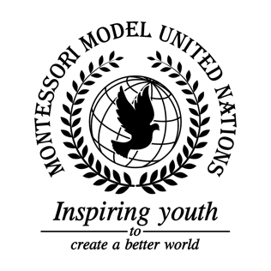

Resolution GA/3/1.1

General Assembly Third Committee
Co-sponsors: Republic of Armenia, Barbados, Republic of Belarus, Belize, Republic of Cameroon, Republic of Colombia, Republic of Cyprus, Czech Republic, Arab Republic of Egypt, Republic of Guinea-Bissau, Islamic Republic of Iran, Ireland, Republic of Kazakhstan, Republic of Latvia, Republic of Lebanon, Libya, Grand Duchy of Luxembourg, Federated States of Micronesia, Republic of Namibia, Federal Democratic Republic of Nepal, New Zealand, Republic of the Philippines, United Kingdom of Great Britain and Northern Ireland
Topic: Improving the Coordination of Efforts Against Trafficking in Persons
The Committee,

Alarmed by the fact that there is an estimate of 40 million slaves worldwide,
Deeply concerned that there were 24.9 million cases of trafficking in persons worldwide in 2017,
Taking into consideration the lack of protection for the victims of trafficking in persons,
Fully aware that 80% of all human trafficking victims are women and girls,
Noting that 99.96% of human trafficking cases go unreported,
Further noting that trafficking in persons brings $32 billion USD per year being the second most profitable crime,

- Emphasizes the importance of raising awareness through advertising, workshops, charity events, school events and through the use of media;
- Recommends countries create licenses for companies to verify that they are not profiting off of trafficking in persons, specifically child labor, with annual inspections to renew licenses;
- Further recommends countries adapt a way for women and girls to file a report against anyone who is forcing them into marriage anonymously;
- Calls upon countries to create rehabilitation centers, homes, safe houses, and shelters for victims of trafficking in persons, focused on mental health, medical needs, education, and protection/safety;
- Invites countries to hold a summit focused on human trafficking to discuss protocols, policies, and create an international human trafficking definition;
- Further invites countries to educate families on safety protocols through workshops and seminars in order to increase safety among citizens;
- Requests countries increase border security to catch smugglers and human traffickers;
- Encourages countries to accept more refugees;
- Suggests a course be made to educate authorities on how to prosecute traffickers and identify human trafficking.

