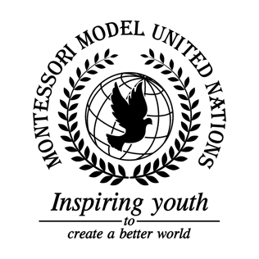

Resolution GA/3/3.1

General Assembly Third Committee
Co-sponsors: Republic of Chile, People’s Republic of China, Federal Democratic Republic of Ethiopia, Republic of Finland, Republic of Honduras, Lao People’s Democratic Republic, Republic of the Marshall Islands, Islamic Republic of Pakistan, Republic of Panama, State of Qatar, Republic of Sierra Leone, Republic of Slovenia, Republic of Tanzania, Ukraine, Oriental Republic of Uruguay, Republic of Vanuatu
Topic: Elimination of Racism, Racial Discrimination, Xenophobia in local communities
The Committee,

Bearing in mind that racism is “taught” not born,
Deeply concerned that communities are separated because of race,
Further recalling that racism still exists among youth,
Aware of excluding material being taught in school,
- Encourages campaigns against racism in school, for example having speakers come in;
- Calls upon teachers to take more action against racism in school;
- Recommends groups and meetings in schools;
- Emphasizes the need for community events to bring people together;
- Further recommends including school curriculum that is inclusive for all cultures.

