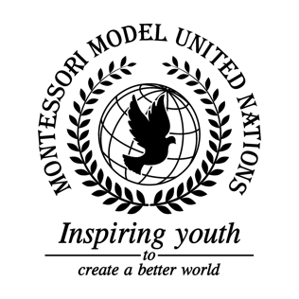

Resolution Food and Agriculture Organization of the United Nations/1.1

Food and Agriculture Organization of the United Nations
Co-sponsors: Kingdom of Belgium, Plurinational State of Bolivia, Republic of Burundi, Central African Republic, Republic of Colombia, Republic of Cyprus, Republic of El Salvador, State of Eritrea, Republic of Finland, Hellenic Republic, Republic of Guinea-Bissau, Republic of Guyana, State of Israel, Republic of Latvia, Republic of Lebanon, Grand Duchy of Luxembourg, Republic of the Marshall Islands, Principality of Monaco, Republic of the Union of Myanmar, Democratic People’s Republic of Korea, Kingdom of Norway, Romania, Republic of Singapore, and Ukraine
Topic: Combating Illegal, Unreported, Unregulated Fishing (IUU)
The Committee,
Taking into consideration that the global economy is affected by Illegal, Unregulated, and Unreported fishing,
Bearing in mind that many people rely on fish on a daily basis,
Alarmed by the large quantity of fish and marine wildlife caught and/or obtained through IUU fishing,
- Emphasizes the need for education and awareness about IUU fishing;
- Endorses the use of satellite vessel monitoring systems for tracking all maritime vessels;
- Recommends using registration numbers to track vessels through all member state’s exclusive economic zones;
- Reminds fisheries that certain areas are restricted for fishing;
- Expresses its hope that member states will continue to enforce and remind fishing laws to fishermen;
- Supports the regulation of the fishing of endangered marine life;
- Calls upon member states to increase fines on fish caught illegally;
- Further invites member states that are able to supply their own patrol personnel to monitor all illegal fishing should do so;
- Trusts that member states enforce that all fishing vessels must be registered in the country they are fishing in;
- Encourages that a portion of the funds produced by the fines of illegally caught fish goes towards ending IUU fishing.

