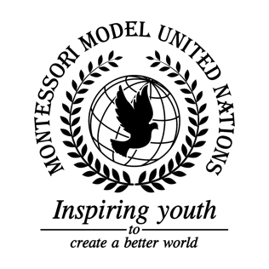

Resolution Economic and Social Council/1.1

Economic and Social Council
Co-sponsors: Republic of Belarus, Belize, Republic of Burundi, Democratic Republic of the Congo, Republic of Cyprus, Czech Republic, State of Eritrea, Republic of Haiti, State of Israel, Jamaica, Republic of Kazakhstan, Republic of Latvia, Republic of Lebanon, Republic of Malta, Kingdom of Morocco, Republic of Portugal, Democratic Republic of São Tomé and Principe, Kingdom of Sweden, United Kingdom of Great Britain and Northern Ireland, Socialist Republic of Viet Nam
Topic: Advancement of Women
The Committee,

Fully aware of the issues caused by forced and underage marriage,
Realizing the full extent of sexual harassment towards women and girls,
Taking into account the lack of respect, rights and laws protecting women and girls,
Observing that women are politically underrepresented,
Recognizing that the gender wage gap is an ongoing issue,
Deeply concerned by the lack of affordable healthcare for young mothers,
Alarmed by the number of women in hostile relationships,
- Recommends that member states individually add a mandatory class explaining sexual harassment and its effects for women and men;
- Supports member states illegalizing dowries;
- Endorses free healthcare for children under the age of eighteen;
- Encourages the creation of a non-profit organization to give women looking to leave a marriage free legal help;
- Encourages women and girls to complete a full education;
- Encourages member states to provide free healthcare for single mothers;
- Calls for increased transparency in discussing wages in a workplace setting;
- Expresses its hope that member states will create and enforce more policies relating to helping women receive childcare;
- Encourages the creation of an organization with the sole purpose of spreading awareness about sexual harassment;
- Expresses hope that member states encourage companies to make wages equal and non-negotiable;
- Calls upon member states to create policies that equally support all with maternity and paternity leave;
- Encourages classes to teach women and girls to take self-defense for when words are not enough;
- Calls upon member states to create laws that encourage companies to make zero-tolerance policies around workplace sexual harassment;
- Deplores member states to create semi-public spaces where everyone can go to either talk about their experiences with sexual harassment or to express if they feel unsafe at in their home;
- Encourages women to speak out about domestic abuse violence and sexual assault;
- Recommends member states to pass laws encouraging all to act equally as guardians;
- Reaffirms the importance of birth control methods in supporting women's rights;
- Suggests eighteen as an international minimum age for marriage;
- Suggests that member states make laws enforcing equal pay for any persons who perform identical jobs;
- Encourages member states to offer free public schooling.

