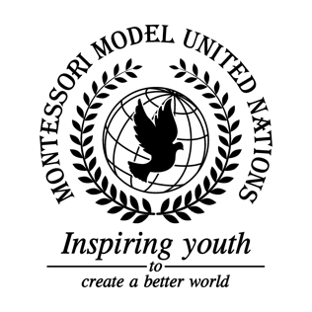

Resolution Economic and Social Council/3.1

Economic and Social Council
Co-sponsors: Barbados, Burkina Faso, Central African Republic, Republic of Chile, People's Republic of China, Republic of Columbia, Dominican Republic, Republic of France, Republic of Honduras, Hashemite Kingdom of Jordan, Republic of Kenya, Laos People's Democratic Republic, Grand Duchy of Luxembourg, Republic of the Marshall Islands, Islamic Republic of Pakistan, State of Qatar, Republic of Sierra Leone, Republic of Slovenia, Republic of South Africa
Topic: Discrimination of Women in Our Communities
The Committee,

Alarmed by the discrimination that girls face in communities,
Noting with deep concern the issue of gender inequality has affected many lives and the environment negatively,
Expressing its appreciation to all countries who take time to focus on this issue,
Seeking more attention from other countries on this issue,

- Expresses its hope on unbiased teachers and environment;
- Encourages schools to enforce rules on any discrimination;
- Further requests that there should be no gender stereotypes;
- Strongly recommends classes about discrimination and sexism on women and
girls;
- Further invites schools around the world to raise money for gender equality to
help raise awareness;
- Consider giving non-gender bathrooms in schools;
- Strongly encourages workshops for teachers about gender equality;
- Approves of co-ed classes/sport teams.

