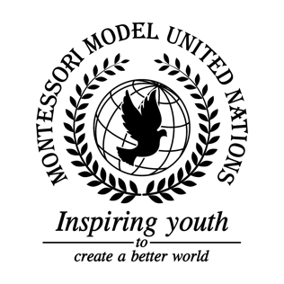

Resolution GA/1/3.1

General Assembly First Committee
Co-sponsors: Republic of Belarus, Republic of Cameroon, Republic of Colombia, Democratic Republic of the Congo, Republic of El Salvador, Republic of France, Georgia, Republic of Guyana, Islamic Republic of Iran, State of Israel, Jamaica, Hashemite Kingdom of Jordan, Republic of Kazakhstan, Republic of Lebanon, Republic of Micronesia, Republic of the Philippines, Republic of Sierra Leone

Topic: Nuclear Disarmament Awareness
The Committee,

Alarmed by the fact that even small nuclear weapons can cause thousands of deaths,
Affirming that modern weapons are more dangerous than ever, especially in space,
Bearing in mind that a missile could come down at any time,
Convinced that education is essential to this issue,
Emphasizing that there are more than 22,000 nuclear weapons worldwide,
Noting with regret that many people are unaware of the extent of destruction that nuclear weapons can cause,
- Encourages communities to offer other less fortunate communities the opportunity to receive education on nuclear disarmament;
- Requests countries to give speeches on the local level;
- Encourages schools to add modern nuclear issues to their curriculum;
- Promotes a Nuclear Weapon Awareness Day on August 6th;
- Recommends promoting nuclear awareness via social media, pamphlets, flyers, posters, websites, and any other methods;
- Endorses fundraising for nuclear awareness with proceeds going to Non-Governmental Organizations (NGOs) of the community’s choice;
- Recognizes that youth play a large role in this issue and recommends that public forums be held, lead and organized by youth.

