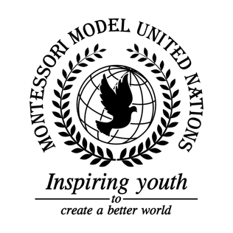

Resolution United Nations Security Council/1.1

United Nations Security Council
Co-sponsors: Kingdom of Belgium, People’s Republic of China, Dominican Republic, Republic of Estonia, Republic of France, Federal Republic of Germany, Republic of Indonesia, Republic of the Niger, Russian Federation, Republic of South Africa, Republic of Tunisia, United Kingdom of Great Britain and Northern Ireland, United States of America, Socialist Republic of Viet Nam
Topic: The Situation in Libya
The Committee,

Noting with regret the number of lives lost in the Libyan Civil War,
Realizing that the ongoing conflict’s effects have spread beyond Libya,
Having considered the amount of money and support that has been given to Libya,
Accepting the challenging circumstances in Libya,
Keeping in mind the topic of the new voting system and reminding those supporting the topic that it will be a backup plan if the governments involved do not wish to combine;

- Recommends ceasefire between the battling political parties;
- Draws the attention to trafficking and smuggling and requests strengthening of border security;
- Recommends the splitting of teachers’ salary between UN funds and property tax;
- Encourages older students to volunteer to teach younger students fundamental skills if not enough teachers are present;
- Emphasizes the importance of child education and invites neighboring or supportive countries to contribute their volunteers to deliver school supplies;
- Supports the proposal to strengthen arms embargo;
- Requests voluntary support from neighboring and supportive countries, and requests materials to support Libya and their humanitarian needs;
- Trusts that the UN can monitor imports and exports, reminding peacekeepers of the proposal to no fire arms;
- Further recommends sanctions on only oil (if the above solutions are not successful);
- Recommends a Libyan co-leader negotiation council;
- Further recommends that all the political leaders get to vote on what kind of governmental system is implemented under UN supervision;
- Draws attention to the prospect of a conference with representatives of the HoR, the GNA, and tribal leaders, under UN supervision;
- Requests a peace summit between all the political representatives of all parties involved, including tribal groups, and encourages them to do so by providing a visual of the effect of the crisis in their country, and reminding them of the fact that the proposal of a new government is possible if the combination of the current governments is not;
- Supports the sending of invitations to a peace summit, stating the importance of the meeting, finding a solution, everyone’s voice being heard, and everyone’s opinion being respected;
- Requests the UN to begin trying to moderate and improve the government.

