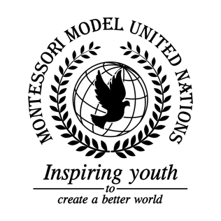

Resolution GA/3/2.1

General Assembly Third Committee
Co-sponsors: Islamic Republic of Afghanistan, Republic of Albania, Principality of Andorra, Plurinational State of Bolivia, Burkina Faso, Canada, Central African Republic, Republic of Costa Rica, Republic of Côte d’Ivoire, Republic of Ecuador, Republic of Equatorial Guinea, Republic of Estonia, Republic of Fiji, Islamic Republic of the Gambia, Federal Republic of Germany, Republic of Guyana, Republic of Iraq, Republic of Kenya, State of Kuwait, The former Yugoslav Republic of Macedonia, Republic of Malta, Republic of Mauritius, United Mexican States, Mongolia, Republic of the Niger, Democratic People’s Republic of Korea, Kingdom of Saudi Arabia, Republic of Senegal, Republic of South Africa, Democratic Socialist Republic of Sri Lanka, Democratic Republic of Timor-Leste
Topic: Elimination of Racism, Racial Discrimination, Xenophobia, and Related Intolerances
The Committee,
Taking into account that many people suffer from racism, xenophobia and related intolerances,
Regretting systematic racism and segregation in the past,
Keeping in mind past efforts against racism that have and have not succeeded,
Further recalling how people of different ethnic groups have been segregated for example couldn’t use the same restroom or sit on the same part of the bus,
Noting with deep concern that this issue takes lives,
Fully aware that all people are born free and have equal rights,
Deeply disturbed by the number of victims of torment, both mental and physical, Observing that xenophobia is a sensitive topic,
Alarmed by the amount of xenophobic people and groups and attacks of specific ethnic groups,
Emphasizing the importance of stopping hate groups,
Deeply regretting the actions of slavery, racism and gender inequality in the past,

- Requests classes educating the children on human rights and the effects of racism;
- Recommends global campaign against racism and xenophobic groups;
- Supports the increase of security in places of worship;
- Expresses its hope for the protection and support of hate crime victims;
- Endorses free mental health support for victims;
- Approves scholarship for the underprivileged;
- Further invites voting rights for all;
- Calls upon the public to support and speak out on the topic of xenophobia and racism using the media;
- Draws the attention to companies using racist policies and unfair pay to profit;
- Emphasizes the fact that the indigenous peoples of countries around the world are the original custodians of the land;
- Requests the option of unisex restrooms in large buildings and schools;
- Encourages countries to communicate with other countries to help stop racism by creating stricter laws and consequences;
- Calls upon peoples and organizations to donate money to the victims of xenophobia for food, clothes, and water;
- Expresses its hope that people will join and lead diverse marches against xenophobia and racism;
- Emphasizes the need for unprejudiced and non-racist law enforcers;
- Requests an expansion on the “School in a Box” program with a worksheet towards education about racism and how it is negatively affecting the world;
- Endorses an outreach program against racism that teaches about it, then takes action via conferences and protesting;
- Encourages fundraising for shelters as a home to people who have suffered from physical abuse and racial discrimination.

