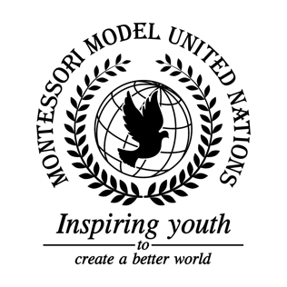

Resolution GA/3/1.1

General Assembly Third Committee
Co-sponsors: Islamic Republic of Afghanistan, Republic of Albania, Principality of Andorra, Plurinational State of Bolivia, Burkina Faso, Canada, Central African Republic, Republic of Costa Rica, Republic of Côte d’Ivoire, Republic of Ecuador, Republic of Equatorial Guinea, Republic of Estonia, Republic of Fiji, Islamic Republic of the Gambia, Federal Republic of Germany, Republic of Guyana, Republic of Iraq, Republic of Kenya, State of Kuwait, The former Yugoslav Republic of Macedonia, Republic of Malta, Republic of Mauritius, United Mexican States, Mongolia, Republic of the Niger, Democratic People’s Republic of Korea, Kingdom of Saudi Arabia, Republic of Senegal, Republic of South Africa, Democratic Socialist Republic of Sri Lanka, Democratic Republic of Timor-Leste
Topic: Improving the Coordination of Efforts Against Trafficking in Persons
The Committee,
Noting with deep concern that many people worldwide are uneducated and are being exploited by human trafficking,
Having adopted the UN treaty for the “protocol to prevent, suppress, and punish trafficking in persons especially in women and children, supplementing the UN convention against organized crime”,
Taking into consideration low levels of border security,
Noting with sorrow the amount of personal information being given away,
Fully aware of the issue of forced labor and forced prostitution,
Alarmed by the millions of people that have been trafficked against their will,
Taking note that having education in all schools around the world for everyone about human trafficking should be essential,
Confident that safety plans could help tracking and working issues out easier when victims have gone missing,
- Promotes higher fundraising levels for victims of trafficking;
- Draws attention to higher border security worldwide, especially in highly populated areas;
- Encourages higher social security regarding personal identification;
- Emphasizes education about human trafficking to identify it easily and to prevent it;
- Endorses healthcare for victims of trafficking, especially victims of prostitution;
- Requests past victims of trafficking to speak up about their traffickers;
- Recommends free weekly self-defense courses for children and additional courses for non-minors;
- Encourages member states to apply stricter laws and punishment against trafficking;
- Calls upon police forces to train officers against human traffickers;
- Encourages Non-Governmental Organizations (NGOs) to help fight human trafficking;
- Emphasizes the need for accessible jobs for all people;
- Confirms that human trafficking is a very big problem and needs to be solved;
- Further invites educational campaigns for people crossing borders;
- Further requests stations at international airports, trains, and cruise ships against human traffickers;
- Recommends shelters are put in place and homes are made for the trafficked victims;
- Encourages job interviews for people in poverty due to trafficking so they don’t get put back in forced labor or prostitution.

