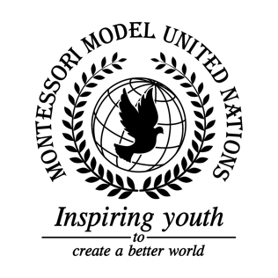

Resolution Economic and Social Council/1.1

Economic and Social Council
Co-sponsors: Islamic Republic of Afghanistan, Republic of Albania, Republic of Argentina, Plurinational State of Bolivia, Republic of Costa Rica,Kingdom of Denmark, Republic of Ecuador, Republic of Estonia, Republic of Fiji, Hellenic Republic, Republic of Guinea, Republic of Guyana, Republic of Iraq, Republic of Italy, State of Kuwait, Republic of Liberia, Republic of Mali, United Mexican States, Mongolia, Democratic People’s Republic of Korea, State of Palestine, Romania, and Republic of Rwanda
Topic: Advancement of Women
The Committee,

Observing the lack of education and female leaders of politics,
Recognizing the issue of domestic violence,
Having examined that women have been hurt,
Realizing the need of education for women around the globe,
Deeply concerned about the lack of education for women,
Deeply disturbed that only 40% of women who are abused ask for help,
Alarmed by the fact that 78% of women in Niger are suffering from child marriage,
Declaring that countries have partnered with UN women and the National Institute of Statistics and Geography (formally known as INEGI),
Noting with deep concern that women who are employed are usually underpaid in comparison
to their male counter parts,
- Authorizes member states to include women’s voices in all political problems;
- Emphasizing the importance of a women’s freedom of choice and for equal rights;
- Calls upon men in the solution to work alongside with women;
- Endorses more schools and jobs to be available for women and girls.

