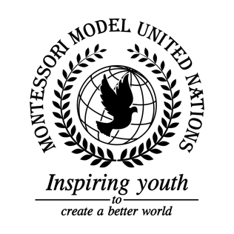

Resolution United Nations Security Council/4.1

United Nations Security Council
Co-sponsors: Kingdom of Belgium, People’s Republic of China, Dominican Republic, Republic of France, Federal Republic of Germany, Saint Vincent and the Grenadines, Republic of South Africa, United Kingdom of Great Britain and Northern Ireland, Socialist Republic of Vietnam
Topic: The Coronavirus
The Committee,

Fully alarmed by the rapid spread of the Coronavirus,
Deeply concerned by Coronavirus’s long incubation period,
Taking into consideration the relative novelty and the mortality rate of the virus,
Convinced of the importance of a global solution in this time of strife,
Keeping in mind the current financial restraints of the United Nations,
Having studied and learned of the more than 80,000 cases,
Desiring a quick and safe end to this virus,
- Calls upon abled UN member states to invest more funding into the WHO;
- Advises public areas to provide hygiene equipment such as hand sanitizers or masks;
- Recommends member states create/enforce public sanitation standards, in facilities such as nursing homes, and other areas with high population densities of the elderly;
- Emphasizes the need for additional endorsement of the World Health Organization;
- Fully believing in the need for health Public Service Announcements on verified platforms in order to spread awareness about the virus;
- Supports mandatory travel bans in areas surrounding large infection centers;
- Authorizes the quarantines of those travelling from areas near Coronavirus infection centers for a minimum of 14 days or until cleared of the virus;
- Designates testing centers in areas with residents infected with the Coronavirus;
- Encourages advertisements that inform the public about Coronavirus hygiene systems instead of solely explaining the severity of the virus.

