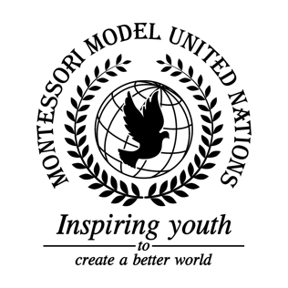

Resolution United Nations Security Council/3.1

United Nations Security Council
Co-sponsors: Kingdom of Belgium, People’s Republic of China, Dominican Republic, Republic of France, Federal Republic of Germany, Saint Vincent and the Grenadines, Republic of South Africa, United Kingdom of Great Britain and Northern Ireland, Socialist Republic of Vietnam
Topic: Conflict and tension between different groups in schools/communities
The Committee,

Emphasizing the need for a strong and supportive school community,
Fully aware of the discrimination in schools around the world,
Alarmed by the effects that bullying has towards children and adults,
Noting with deep concern, the systemic prejudices that bullying has created,
Bearing in mind that schools should be a safe environment for all children,
Emphasizing the necessity for teacher and peer support,
- Endorses the training of teachers to recognize discrimination and bullying in school;
- Requests the development of integrated athletics and extra-curricular activities at school;
- Calls upon schools to encourage kindness and acceptance in kids at a young age;
- Emphasizes the need for team-building activities at school;
- Reaffirms the need for a safe space and access to counselling in schools globally;
- Confirms the need for growth in school exchange programs.

