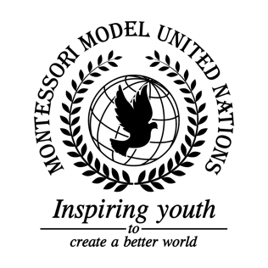

Resolution United Nations Human Rights Council/3.1

Human Rights Council
Co-sponsors: Republic of Belarus, Canada, Republic of Chile, Czech Republic, State of Eritrea, Federal Republic of Germany, Republic of Honduras, Republic of Kazakhstan, Republic of Lebanon, Federated States of Micronesia, Federal Democratic Republic of Nepal, Republic of the Philippines, Romania, Kingdom of Saudi Arabia, Republic of South Sudan, Kingdom of Switzerland, Ukraine, United Kingdom of Great Britain and Northern Ireland, Socialist Republic of Viet Nam
Topic: Media Literacy
The Committee,

Fully aware that the spread of false information has become more prominent since the advancement of technology,
Bearing in mind that the majority of the population has access to both accurate and inaccurate news,
Observing that 95% of information is digitalized, and considering that 2.26 billion people use Facebook, with some people using it as a news outlet,
Noting the fact that everyone has the right to freedom of speech according to the Declaration of Human Rights,
Noting that the internet and social media platforms are common outlets that can easily spread and be believed by the public,
Deeply concerned that some news agencies can be biased and are the primary cause of the spread of false information,
Keeping in mind that the entire population isn’t fully aware of the rapid spread of false information,

- Calls upon news agencies to obtain a certain level of verification to be able to publish information;
- Encourages readers and users to be aware of their sources of information;
- Further recommends the usage of search engines that can filter credible and non-credible sources of information;
- Reminds that readers should investigate the origin of the article;
- Emphasizes the need for the creation of a site with a list of sources that are reputable.

