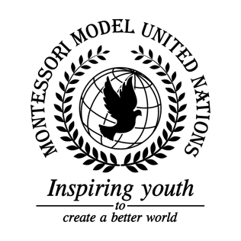

Resolution United Nations Human Rights Council/2.1

Human Rights Council
Co-sponsors: Republic of Belarus, Canada, Republic of Chile, Czech Republic, State of Eritrea, Federal Republic of Germany, Republic of Honduras, Republic of Kazakhstan, Republic of Lebanon, Federated States of Micronesia, Federal Democratic Republic of Nepal, Republic of the Philippines, Romania, Kingdom of Saudi Arabia, Republic of South Sudan, Kingdom of Switzerland, Ukraine, United Kingdom of Great Britain and Northern Ireland, Socialist Republic of Viet Nam
Topic: The Situation in Yemen
The Committee,

Noting with deep concern that the crisis in Yemen is the largest humanitarian situation in the world, with over 24 million in need of assistance,
Recognizing the fact that more than 350,000 children under the age of 5 are suffering from acute malnutrition and that 4.7 million are in need of educational assistance,
Taking note that Yemen has failed in its obligation to respect, protect, and fulfill the articles of the Universal Declaration of Human Rights,
Fully aware of the difficult political standpoint in Yemen due to the Houthi rebels,
Deeply concerned by the interventions held in Yemen including airstrikes and blockades with the proclaimed objective of restoring former President Abdrabbuh Mansour Hadi’s power to the government,
Alarmed that the people of Yemen have been in a civil war since 2015,
Taking into account that the blockades prevent ships from entering Yemen’s ports, meaning which means that no medicine, food, water, or other resources can enter the country,
Expressing its appreciation to all delegations for debating, compromising, and working together to solve this complex, yet important issue,
Bearing in mind that homes, factories, farmland, schools, hospitals, and other vital infrastructure are being destroyed, further fracturing the economy,
Noting with deep concern how famine is rising and cholera is threatening many people in Yemen with these issues being by-products of the flawed Human Rights situation in Yemen,
Noting the fact that the United Nations is a non-governmental organization that will remain a neutral body, focusing on those suffering in Yemen and to re-establish their rights and the quality of living,

- Requests that all willing member states, as well as the United Nations, begin helping and supporting Yemeni families, and civilians by sending resources including: food, water, medical supplies as well as financial support through the Department of International Development;
- Recommends Yemen and other member states actively involved in the conflict implement articles 22, 25, 26, 28, and 29 from the Universal Declaration of Human Rights more effectively;
- Encourages countries to comply and enforce the rules and regulations regarding Security Council resolution 2216, especially emphasizing the section that “calls upon all Yemeni parties, in particular, the Houthis, to abide by the Gulf Corporation Council Initiative and its implementation mechanism”;
- Calls upon Gulf countries to come together annually to discuss the progress of significant issues, as well as set clear objectives on how to improve the crisis especially regarding regulations on arms that are being sent to Yemen and on child soldiers;
- Draws the attention to the United Nations as a request that Peacekeepers be sent to Yemen when the consequential conflict is relieved, in order to contribute to an effective and fast recovery;
- Further reminds that neighboring countries who are willing to provide safe zones for endangered Yemeni people should do so;
- Expresses its ideas to news agencies and social media platforms to educate people and facilitate conversations about the pressing crisis in Yemen;
- Authorizes that a ceasefire, as well as a summit, must be held to resolve the political conflicts between the different parties.

