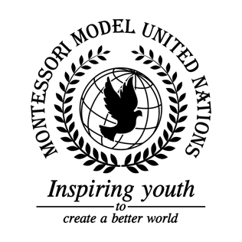

Resolution United Nations Human Rights Council/2.1

Human Rights Council
Co-sponsors: Kingdom of Belgium, Federative Republic of Brazil, People’s Republic of China, Republic of El Salvador, Republic of Haiti, Ireland, Hashemite Kingdom of Jordan, Republic of Kenya, Lao People’s Democratic Republic, Libya, Grand Duchy of Luxembourg, Republic of the Marshall Islands, Kingdom of Morocco, Islamic Republic of Pakistan, State of Qatar, Saint Vincent and the Grenadines, Democratic Republic of São Tomé and Príncipe, Republic of Sierra Leone, Republic of Slovenia, Republic of the Sudan, Republic of Tajikistan, and the United Republic of Tanzania.
Topic: The Human Rights Situation in Yemen
The Committee,

Noting with regret the continuation of the conflict between the Houthis and other parties including Saudi Arabia in Yemen,
Deeply Alarmed by the numerous violations of the Universal Declaration of Human Rights occurring in Yemen,
Viewing with appreciation the charitable assistance and aid of multiple NGOs for the innocent Yemeni citizens people in need,
Emphasizing the cooperation needed from all nations for easing and ultimately resolving The Human Rights Situation in Yemen,
Taking into consideration that Yemen is lacking the basic Sustainable Development Goals such as, SGD 2 (zero hunger), SDG 3 (good health and well-being), SDG 6 (clean water and sanitation), SDG 8 (decent work and economic growth) and SDG 16 (peace justice and strong institutions),
1. Encourages organizations like Doctors Without Borders to support Yemeni people in need;
2. Proclaims that member nations raise awareness regarding the Saudi Arabian blockade as well as child soldiers to the public;
3. Suggests the enactment of annual conferences to discuss the Human Rights Situation in Yemen;
4. Calls upon Saudi Arabia to allow multiple Yemeni people out of Yemen as refugees;
5. Expresses its hope to raise awareness to the issue of the recruitment of child soldiers by bringing it to the attention of the International Court of Justice and/or the Security Council;
6. Recommends negotiations with secondary parties to lift the blockade through new monetary policies for aforementioned parties.

