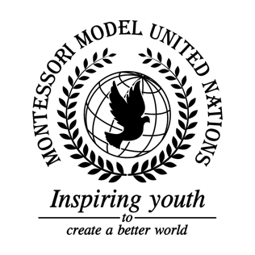

Resolution United Nations Human Rights Council/1.1

Human Rights Council
Co-sponsors: Kingdom of Belgium, Federative Republic of Brazil, Republic of El Salvador, Republic of France, Republic of Haiti, Ireland, Hashemite Kingdom of Jordan, Republic of Kenya, Lao People’s Democratic Republic, Libya, Grand Duchy of Luxembourg, Republic of the Marshall Islands, Kingdom of Morocco, Islamic Republic of Pakistan, State of Qatar, Saint Vincent and the Grenadines, Democratic Republic of São Tomé and Príncipe, Republic of Sierra Leone, Republic of Slovenia, Republic of the Sudan, and the United Republic of Tanzania
Topic: Safety of Journalists
The Committee,

Reaffirming Article 19 of the Declaration of Human Rights, which concerns the right to press freedom,
Noting with deep concern the inhumane treatment of journalists,
Desiring the help and cooperation of all member nations to resolve this conflict,

- Calls upon the United Nation’s collaboration with charitable companies to advocate for the safety of journalists;
- Encourages raising awareness on social media platforms while informing the government along with the general public regarding the harmful treatment of journalists;
- Further recommends that each country is held responsible for the unalienable safety and actions taken by journalists;
- Requests for the arming of journalists accordingly for life threatening or unstable circumstances provided by a UN sponsored NGO;
- Suggests a self-defense and education of martial arts training for journalists while obtaining a degree in journalism.

