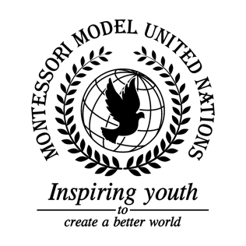

Resolution GA/3/1.1

General Assembly Third Committee
Co-sponsors: Islamic Republic of Afghanistan, Republic of Albania, Plurinational State of Bolivia, Central African Republic, Republic of Costa Rica, Republic of Cote d’Ivoire, Republic of Estonia, Republic of Fiji, Federal Republic of Germany, Republic of Iraq, Republic of Kenya, State of Kuwait, The former Republic of Macedonia, Republic of Malta, Republic of Niger, Democratic People’s Republic of Korea, Kingdom of Saudi Arabia, Slovak Republic, Republic of South Africa, Democratic Socialist Republic of Sri Lanka, Democratic Republic of Timor-Leste
Topic: Improving the Coordination of Efforts Against Trafficking in Persons
The Committee,

Noting with deep concern human trafficking is a major issue in our society,
Taking this problem into consideration traffickers mostly target women, children and impoverished groups,
Keeping in mind the victims who have suffered from trafficking the committee should drive to build more rehabilitation centers with professional security,
Alarmed by the existence of many sides of human trafficking the committee should put forced labor into extreme consideration,
Deeply disturbed by organ removal, prostitution and forced marriage are done when people are trafficked,
Keeping in mind that human trafficking is done because it is extremely profitable for the traffickers and it is a multibillion-dollar industry,
Considering that teachers should educate how to defend themselves and their students by creating a class specialized in self-defense against human traffickers,
- Further invites governments to create more rehabilitation centers and shelters for trafficking victims;
- Encourages citizens to donate funds to support trafficking victims;
- Approves more police investigation for trafficking;
- Recommends making a task force focusing mainly on human trafficking;
- Considers more jobs and better education in communities;
- Encourages spreading awareness about human trafficking and how to prevent it through education, campaigns and advertisements;
- Requests that we stop the prosecution of victims of human trafficking;
- Supports school systems to require ID at dismissal;
- Taking note of the fact that women and children need to be better prepared and protected;
- Draws attention to giving people the resources they need to further protect themselves against human trafficking such as a personal hotline;
- Further encourages the justice system to increase the penalty for trafficking persons;
- Endorses patrols in proven high risks areas;
- Recommends that schools, homes and colleges have different and stronger security systems;
- Calls upon weapon stores to have a better ID security system;
- Draws attentions to the fact that countries need more homeless shelters in impoverished areas;
- Calls upon the countries of the world to sign more treaties and establish more laws to prevent this crisis;
- Requests to enhance border security with personnel education on human trafficking;
- Further recommends that there be a 10-year minimum sentence for traffickers;
- Highly recommends raising awareness in trafficking in persons by implementing more education on this topic into our school systems.

