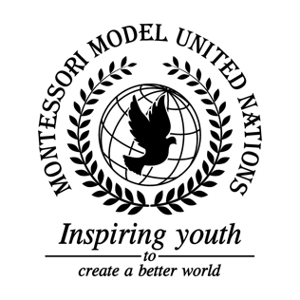

Resolution GA/3/2.1

General Assembly Third Committee
Co-sponsors: Republic of Austria, Kingdom of Bahrain, Federative Republic of Brazil, Republic of Bulgaria, Democratic Republic of the Congo, Republic of Cuba, State of Eritrea, Georgia, Republic of Haiti, Republic of India, Japan, Principality of Monaco, Republic of the Union of Myanmar, Sultanate of Oman, Romania, Kingdom of Sweden
Topic: Elimination of Racism, Racial Discriminations, Xenophobia, and Related Intolerance
The Committee,

Deeply disturbed by the amount of racism in the world,

Keeping in mind that this the issue of racism is happening occurring all over the world,

Recognizing the fact that racism destroys human dignity,

Bearing in mind that there are two different types of racism which are called overt and covert,

Believing that ending racism will solve many more issues such as human trafficking and gender inequality,

Taking into account that racism can happen anywhere around the world,

Alarmed by the increasing amount of racism and xenophobia in the world around us,

- Encourages schools to make a program that will teach children to accept all races and cultures;
- Designates all citizens to give out equal opportunities and jobs with fair pay policies;
- Recommends all forms of media and citizens to not use racist language;
- Encourages countries to fund positive media that shows all kinds of people interacting;
- Considers creating documentaries about every country, religion and culture;
- Calls upon the fact that jail time should be longer for racism and discrimination purposes;
- Emphasizes financial incentives for anti-racism and discrimination classes;
- Encourages all schools to accept children of different races and genders so they can come together;
- Calls upon all communities to accept all religions, races, cultures, genders and ethnic groups;
- Further requests should be made by the governments to make safe centers and places for people for who are being abused through racism, discrimination, and xenophobia;
- Requests to celebrate, in schools and businesses, cultural events and holidays.

