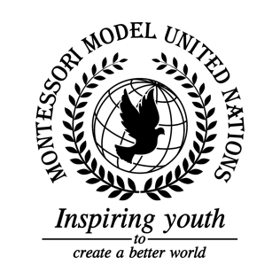

Resolution Economic and Social Council/1.1

Economic and Social Council
Co-sponsors: Republic of Angola, Republic of Armenia, Commonwealth of the Bahamas, Kingdom of Bahrain, Republic of Botswana, Federative Republic of Brazil, Republic of Bulgaria, Republic of Cameroon, Republic of Cuba, Arab republic of Egypt, Republic of Finland, Georgia, Republic of Iceland, Republic of India, Japan, Republic of the Union of Myanmar, Kingdom of the Netherlands, New Zealand, Sultanate of Oman, Russian Federation, Ukraine
Topic: Advancement of Women
The Committee,

Recognizing that the problem of discrimination against women needs to be solved,
Deeply concerned about the lack of advantages that women have,
Emphasizing the influence of the Convention on the Elimination of All Forms of Discrimination Against Women,
Fully believing that we can create a successful resolution to help achieve gender equality,
- Recommends building shelters for the purpose of protecting women and girls, and giving them a safe environment to recover from abuse or poverty;
- Encourages facilities for educating women and girls in life skills and self-defense as well as reading writing and math;
- Calls upon organizations to create more fundraisers to help women and girls;
- Requests that countries build inexpensive hospitals that have the necessary equipment to aid impoverished women in all conditions of health,
- Further requests to create a declaration similar to the Declaration of Human Rights focused on the rights of women and girls;
- Calls upon organizations to raise awareness about the discrimination women face;
- Encourages governments to raise awareness to give women financial independence by giving them bank accounts and decreasing the pay gap and creating equal employment between men and women;
- Considers creating an international equality day;
- Supports the creation of a treaty to make a certain percentage of jobs available to women in each member state worldwide.

