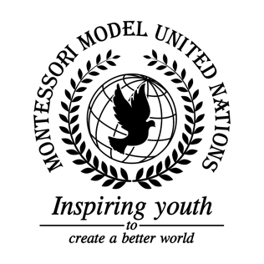

Resolution Economic and Social Council/2.1

Economic and Social Council
Co-sponsors: Republic of Albania, Republic of Argentina, Plurinational State of Bolivia, Republic of Costa Rica, Republic of Estonia, Federal Democratic Republic of Ethiopia, Republic of Fiji, Republic of Iraq, Republic of Italy, State of Kuwait, Principality of Monaco, Republic of Mozambique, Democratic People’s Republic of Korea, Romania, Republic of Rwanda, Kingdom of Saudi Arabia
Topic: United Nations Forum on Forests
The Committee,

Deeply regretting that a forested area the size of England is lost globally each year,
Recognizing that wildlife and indigenous people living in the forest are losing their homes and habitats,
Deeply concerned that many forests will soon be gone,
Taking into account that 1.6 Billion people and 80% of terrestrial species rely on forests for their survival,
Noting with deep concern that we are rapidly nearing the deadline for Sustainable Development Goals 3,7,11,12,13, and 15,
Seeking ways to protect the forests,
- Calls upon member states’ governments to support reforestation;
- Encourages member states to reuse, recycle, and be sustainable;
- Suggests making campaigns that educate people about deforestation and support reforestation;
- Recommends member states and their citizens to donate to reforestation efforts;
- Endorses investigations on illegal loggers;
- Emphasizes that communities use natural fertilizer and organic weedkiller instead of the slash and burn method;
- Requests member states to lower the budget of legal loggers;
- Calls upon member states recycle the stalks of grains and plastics for use as building materials;
- Supports the reduction of coal mining;
- Further requests that amendments be made to the Paris Agreement to outline specific actions that countries should take to reach their original goal by 2030.

