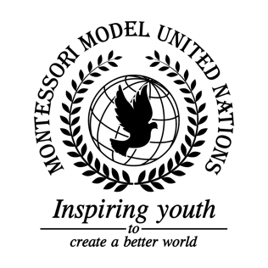

Resolution Economic and Social Council/1.1

Economic and Social Council
Co-sponsors: Republic of Albania, Republic of Argentina, Plurinational State of Bolivia, Republic of Costa Rica, Republic of Estonia, Federal Democratic Republic of Ethiopia, Republic of Fiji, Republic of Iraq, Republic of Italy, State of Kuwait, Principality of Monaco, Republic of Mozambique, Democratic People’s Republic of Korea, Romania, Republic of Rwanda, Kingdom of Saudi Arabia
Topic: Advancement of Women
The Committee,

Taking into account that women are often not seen as equal to men,
Emphasizing that women and girls deserve but often do not receive equal opportunities and rights as men,
Noting with regret, girls are being forced into marriage when they are underage,
Alarmed by the proximity of the final deadline for Sustainable Development Goal 5,
Bearing in mind that there is gender inequality all throughout the world,
Noting with the deep concern that women are being mistreated,
Recognizing the poverty that some females have to face,
Further reminding that women and girls are often targets of abuse and/or human trafficking,
Drawing the attention to the poverty women face,
- Reminds that member states provide education and training for jobs to girls and women;
- Calls countries to close the gender wage gap;
- Emphasizes on the medical rights of women and provide midwifes and midwifery kits;
- Requests both parents take care of their children equally;
- Encourages women and girls to stand up for their selves and use their voice;
- Further recommends that governments have effective mechanisms available to investigate abuse;
- Calls upon countries to put together organizations to help women and girls out of poverty;
- Further proclaims that governments should support women’s rights NGOs;
- Requests governments to educate men and women about gender inequality;
- Strongly disagrees with marriage and pregnancy for people under the age 19.

