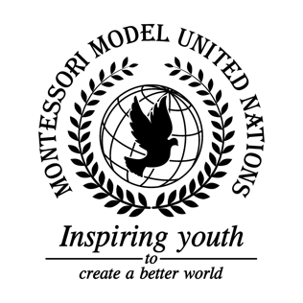

Resolution Food and Agriculture Organization of the United Nations/2.1

Food and Agriculture Organization of the United Nations
Co-sponsors: Republic of Angola, Republic of Austria, Belize, Republic of Cameroon, Republic of Chile, People’s Republic of China, Democratic Republic of the Congo, Dominican Republic, Republic of Croatia, Republic of Cuba, Republic of Estonia, Federal Republic of Germany, Republic of Honduras, Hungary, Republic of India, Republic of Iraq, Ireland, Republic of Kazakhstan, Lao People’s Democratic Republic, Republic of North Macedonia, Federal Democratic Republic of Nepal, New Zealand, Republic of the Philippines, Independent State of Samoa, Republic of Serbia
Topic: The State of Food Security and Nutrition in the World
The Committee,

Having adopted programs for food security,
Declaring investments in farming technology,
Bearing in mind donations to kids at poor schools for free,
Desiring donations of unwanted food every month to poor countries,
Further recommends that the UN donates meals on a daily basis,

- Encourages many food drives;
- Consider using some tax to feed the food insecure people and families;
- Considers that the UN helps prevent desertification by limiting climate change through the Paris Agreement;
- Requests meals on holidays for people facing food insecurity;
- Encourages that the UN builds homes for the hungry where they can be fed and cared for.

