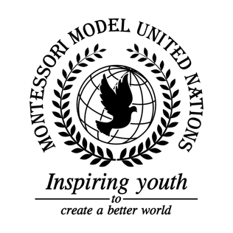

Resolution Food and Agriculture Organization of the United Nations/1.1

Food and Agriculture Organization of the United Nations
Co-sponsors: Republic of Angola, Republic of Austria, Belize, Republic of Cameroon, Republic of Chile, People’s Republic of China, Democratic Republic of the Congo, Dominican Republic, Republic of Croatia, Republic of Cuba, Republic of Estonia, Federal Republic of Germany, Republic of Honduras, Hungary, Republic of India, Republic of Iraq, Ireland, Republic of Kazakhstan, Lao People’s Democratic Republic, Republic of North Macedonia, Federal Democratic Republic of Nepal, New Zealand, Republic of the Philippines, Independent State of Samoa, Republic of Serbia
Topic: Illegal, Unreported, and Unregulated Fishing
The Committee,

Bearing in mind people should stop trawling,
Having considered to monitor fish stocks,
Keeping in mind ghost nets should be prohibited,
Having considered station officers for boats to check IDs in or around the water,

- Considers having a floating border allowing boats with proper registration to enter and be checked;
- Requests having trackers for fishing vessels;
- Encourages that every month only certain fish can be caught;
- Requests that all boats except for cruise ships and houseboats shall be questioned for being on the water for more than three days;
- Encourages giving people the knowledge that grocery stores refrain from getting shipments from unsustainable fisheries.

