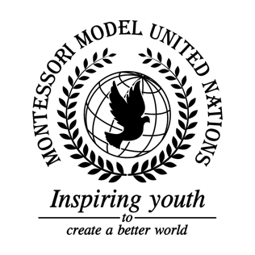

Resolution Food and Agriculture Organization of the United Nations/2.1

Food and Agriculture Organization of the United Nations
Co-sponsors: Commonwealth of Australia, Republic of Botswana, Federative Republic of Brazil, Republic of Bulgaria, Republic of Costa Rica, Republic of Côte d’Ivoire, Arab Republic of Egypt, Federal Democratic Republic of Ethiopia, Republic of Fiji, Republic of France, Georgia, Republic of Haiti, Republic of Iceland, Islamic Republic of Iran, Republic of Italy, Republic of Kenya, Libya, Republic of Nauru, Kingdom of the Netherlands, Sultanate of Oman, Russian Federation, Republic of Slovenia
Topic: The State of Food Security and Nutrition in the World
The Committee,

Keeping in mind that 1out of every 7 people are starving,
Deeply concerned that ⅓ of all food is wasted,
Having adopted zero hunger as the second Sustainable Development Goal,
Realizing that only 40% of the world has enough food to eat,

- Supports education on food security and nutrition, therefore people will know what a balanced diet and food security is;
- Requests aid workers from developed countries and the United Nations;
- Recommends no harmful pesticides in food;
- Encourages trying to stop deforestation and climate change;
- Further invites outdoor, indoor, and community greenhouses and gardens;
- Authorizes storing food and water underground in case of droughts and famines;
- Endorses installing more artesian wells and making more water filters;
- Considers the use of land and water resources for farming and fishing;
- Emphasizes writing peace treaties so that farmers will not flee from their farms due of war;
- Draws the attention to selling less junk food in stores;
- Authorizes taking grocery stores’ extra food and giving it to food banks which will distribute the food to poor families.

