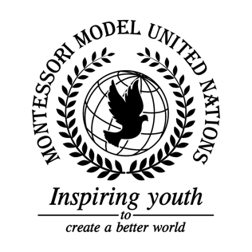

Resolution United Nations Office on Drugs and Crime/2.1

United Nations Office on Drugs and Crime
Co-sponsors: Republic of Armenia, Republic of Benin, Bosnia and Herzegovina, Burkina Faso, Kingdom of Cambodia, Central African Republic, Republic of Chad, Republic of Chile, People’s Republic of China, Arab Republic of Egypt, Republic of El Salvador, Federal Democratic Republic of Ethiopia Federal Republic of Germany, Republic of Ghana, Republic of Haiti, Japan, State of Kuwait, Republic of Lebanon, Principality of Monaco, Republic of the Union of Myanmar, Republic of Nicaragua, Republic of Portugal
Topic: Preventing and Combating Trafficking in Human Organs and Trafficking in Persons for the Purpose of Organ Removal
The Committee,

Referring to organ trafficking as the illegal obtaining of an organ with means including, but not limited to the pressuring of individuals and deceit,
Alarmed by the increasing number of individuals who have been affected by this global issue,
Bearing in mind the previous resolutions that have been put in place,
Expressing its desire of global cooperation in order to eradicate organ trafficking,
Taking into consideration the many suggestions put forward by all nations,
Having studied the causes and effects of human organ trafficking,
- Requests nations to implement educational programs to raise global awareness regarding organ trafficking;
- Calls upon all nations to use different medias, such as news programs, leaflets, and social media for the purpose of increasing domestic awareness;
- Strongly recommends nations to aid the victims of organ trafficking through rehabilitation and seminars;
- Emphasizes the need for higher and more efficient security and stricter laws regarding organ trafficking;
- Further recommends constantly recurring mandatory check-ups on the medical personnel;
- Encourages funding for research projects to prevent organ trafficking;
- Calls upon countries to create regional organizations, in order to raise awareness on the topic;
- Encourages member states to support developing countries in order for them to have the facilities to eradicate organ trafficking;
- Emphasizes the need for nations to create a road map of goals to meet in a certain time period;
- Highlights the need for all nations to implement their own opt-in/opt-out system depending on their circumstance;
- Further invites all nations to implement the 11 principles of organ transplantation by the World Health Organization;
- Further requests funds for developing organ-transplantation technology.

