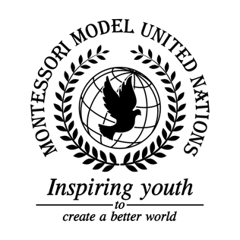

Resolution GA/3/3.1

General Assembly Third Committee
Co-sponsors: Republic of Armenia, Republic of Azerbaijan, Commonwealth of the Bahamas, Republic of Belarus, Belize, Kingdom of Bhutan, Republic of Cameroon, Republic of Colombia, Republic of Cyprus, Czech Republic, Arab Republic of Egypt, Republic of Kazakhstan, Republic of Latvia, Republic of Lebanon, Libya, Grand Duchy of Luxembourg, Islamic Republic of Mauritania, Republic of Namibia, Federal Democratic Republic of Nepal, New Zealand, Republic of Palau, Republic of the Philippines, United Kingdom of Great Britain and Northern Ireland
Topic: The Elimination of Racism, Intolerance and Xenophobia in schools and communities
The Committee,
Observing that many schools experience racial discrimination,
Noting with deep concern the intolerances that exist in many communities,
Realizing that many forms of discrimination take place,
Taking into consideration that many people do not accept immigrants,
Having devoted attention to creating less intolerant communities,

- Recommends that schools enforce stricter rules regarding racial intolerance;
- Calls upon communities to accept all cultures;
- Encourages schools to create stricter punishments for those who use racial, homophobic, or sexist slurs;
- Expresses its hope that schools teach students about sexuality and racial diversity;
- Further requests that schools bring in professionals on these topics to educate students.

