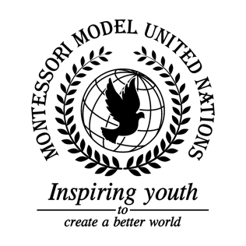

Resolution GA/3/2.1

General Assembly Third Committee
Co-sponsors: Republic of Chile, People’s Republic of China, Republic of Djibouti, Federal Democratic Republic of Ethiopia, Grenada, Republic of Honduras, Hungary, Republic of Indonesia, Lao People’s Democratic Republic, Principality of Liechtenstein, Republic of Mali, Republic of the Marshall Islands, Kingdom of the Netherlands, Islamic Republic of Pakistan, Republic of Panama, State of Qatar, Russian Federation, Republic of Rwanda, Republic of Serbia, Republic of Sierra Leone, Republic of Slovenia, Solomon Islands, Republic of the Sudan, Republic of Tajikistan, United Republic of Tanzania, Ukraine, Oriental Republic of Uruguay, Republic of Vanuatu
Topic: Elimination of racism, racial discrimination, xenophobia and related intolerance
The Committee,

Believing that all human beings should be treated equally,
Alarmed by the rapidly increasing number of hate crimes occurring worldwide,
Aware of the suffering victims face due to racial discrimination throughout time,
Acknowledging the previous efforts made by member states to prohibit and eliminate discrimination,
Keeping in mind that racial discrimination, xenophobia and related intolerances are worldwide issues,
Deeply concerned by the use of the internet platforms to promote racism,
Viewing with appreciation of the previous efforts to eliminate ethnic inequalities through the convention on the elimination of all forms of racial discrimination,
Deeply disturbed by the number of racial slurs used every day,
Reminding member states that people should be accepted for their differences,

- Encourages that states guarantee that the equality of human and civil rights and freedoms, regardless of someone’s race, nationality, language, origin, financial, or official status, place of residence, attitude to religious beliefs, membership of public associations and other circumstances;
- Strongly suggests that governments inside of the UN should share information especially regarding extremists groups, and would like to put a legislation in place to limit the organizing of protest involved with hate groups.;
- Urge all members of the committee to provide first responders with training on how to handle extremist political groups;
- Encourages the creation of educational programs in schools that cover topics such as racism, xenophobia, discrimination, and related intolerance;
- Requests background checks on all teachers to ensure that they are certified for their jobs and do not influence discriminatory opinions on children;
- Supports the implementation of awareness campaigns;
- Emphasizes the removal of vandalism that could be perceived as offensive towards groups of people;
- Further requests the creation of a website database that is easily accessed by all UN member states that documents hate crimes and information on law enforcement and justice;
- Further requests the efforts to desegregating communities through fundraising;
- Further invites the MINUSMA to become international;
- Emphasizes the importance of reviewing school curriculums for racist comments and opinions;
- Draws the attention to the positive effects that microloans can have on small businesses.

