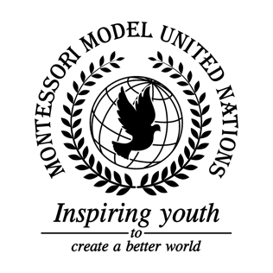

Resolution GA/3/1.1

General Assembly Third Committee
Co-sponsors: Republic of Chile, People’s Republic of China, Republic of Djibouti, Federal Democratic Republic of Ethiopia, Grenada, Republic of Honduras, Hungary, Republic of Indonesia, Lao People’s Democratic Republic, Principality of Liechtenstein, Republic of Mali, Republic of the Marshall Islands, Kingdom of the Netherlands, Islamic Republic of Pakistan, Republic of Panama, State of Qatar, Russian Federation, Republic of Rwanda, Republic of Serbia, Republic of Sierra Leone, Republic of Slovenia, Solomon Islands, Republic of the Sudan, Republic of Tajikistan, United Republic of Tanzania, Ukraine, Oriental Republic of Uruguay, Republic of Vanuatu
Topic: Improving the Coordination of Efforts Against Trafficking in Persons
The Committee,

Taking the Social Humanitarian, into consideration, the problem of Human Trafficking in the 21st century,
Deeply concerned by the number of human trafficking events occurring in the world,
Aware of the danger people face due to unemployment and lack of education,
Noting with deep concern that the majority of trafficked victims are women and children,
Realizing that trafficking people has evolved into a type of modern slavery today,
Fully aware of the fear that victims face to reveal the truth about being trafficked,
Expressing the importance of signing the Palermo Protocol to prevent, suppress, and punish trafficking in person, that puts special protection on people,
Taking note of the trauma victims experience through human trafficking,
Deeply disturbed by actions victims are forced to participate in,
- Calls upon the UN to establish an awareness campaign directed towards children, who -- if under the age of 13 -- would need parental consent in order to receive this education;
- Encourages governments to implement identification and protection procedures into the curriculum;
- Drawn the attention to redistribute old textbooks to primarily provide education for those in need in underdeveloped areas;
- Strongly recommends for the UN to support NGOs and charitable organizations through trans-national educational organizations centered around trafficking in persons;
- Encourages the building of academic institutions in developing areas to increase job and education opportunities;
- Considers that the majority of people trafficked are in poverty, and suggests that the UN and NGOs work with developing nations to ensure economic security by funding for programs to teach people about finances and how to properly sustain their money for their future;
- Encourages member states to implement the Lichtenstein Initiative to help locate and prosecute traffickers;
- Further invites countries to increase surveillance at strategical spots by the implementation of security cameras and other equipment, and the reinforcing of border security through the capacitation of border patrol and security units in order to identify suspicious behaviors;
- Encourages countries to organize surprise covert operations and audits in and around human trafficking hotspots with undercover agents and police in order to gather information and plan operations to reduce human trafficking;
- Endorses the improvement and strengthening of law enforcement systems by creating better legislations and reinforcing already existing ones with loopholes that allow offenders to get away with their crime;
- Expresses its hope for countries to adopt reintegration programs to help victims that have escaped this situation by offering medical, physical, and psychological treatment, offering group talks and anonymous sponsor guidance and providing a safe place for people to stay before reintegrating to society;
- Recommends that the UN promotes funding to the Blue Campaign, which is in charge of tracking and tackling cases of human trafficking.

