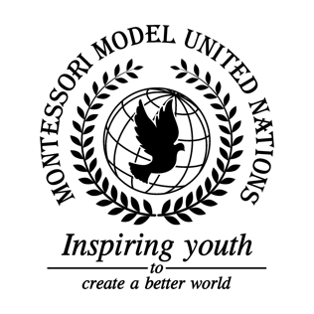

Resolution Economic and Social Council/1.1

Economic and Social Council
Co-sponsors: Common Wealth of Australia, Barbados, Burkina Faso, Central African Republic, The Republic of Chile, The Republic of Equatorial Guinea, The Republic of The Gambia, The Republic of Honduras, Hungary, The Republic of Indonesia, Republic of Kenya, The Grand Duchy of Luxembourg, Republic of the Niger, The Republic of Serbia, The Republic of Sierra Leone, The Republic of South Africa
Topic: Advancement of Women
The Committee,

Alarmed by the fact that 1 in 3 women face physical or sexual abuse in their lifetime,
Convinced that every female should have freedom of speech,
Deeply concerned by men’s dominance over women,
Having considered that the male to female pay gap is still relevant,
Recognizing past events that have strengthened women’s rights,
Emphasizing the fact that women are being objectified by the media,
Fully alarmed by a lack of safety in school and work environments,
Welcoming change and new ideas to better women’s rights,
Emphasizing the lack of feminine necessities, such as birth control and sanitary products,
Noting with deep concern the absence of quality standards in women’s restrooms,
Keeping in mind the abundance of abuse cases in foster homes,
Taking into account that women everywhere are experiencing all sorts of violence, and very little is being done about it,
Deeply concerned by the lack of educational opportunities for women world-wide,
- Encourages all UN member states, to set new standards for school bathrooms;
- Recommends all UN member states to introduce an alternate to FGM rituals;
- Recommends that all UN states conduct health/welfare checkups through surveys;
- Request that all UN member states allow their citizens to safely access birth control and sanitary supplies;
- Request that all UN member states provide their citizens with a payed maternity leave;
- Encourages all UN member states to educate citizens, particularly students about menstrual health, sexual health and motherhood;
- Emphasizes the need for online schools and websites;
- Strongly suggests that UN members bring in major figures to speak/empower women;
- Calls upon UN member states to create safe spaces, such as women only shelters;
- Calls upon UN member states to put funding into a sexual violence/ safety hotline;
- Encourages the creation of wellness centers in schools;
- Draws the attention of the public towards the issue of gender discrimination;
- Encourages UN member states to establish a movement that works to stop domestic violence and other related issues;
- Supports the 3% of countries that have achieved gender equality;
- Requests the support of UN member states in allowing women to have autonomy over their own bodies, and a voice in making decisions that will affect their lives.

