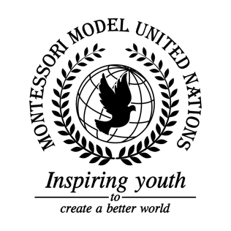

Resolution GA/1/1.1

General Assembly First Committee
Co-sponsors: Commonwealth of Australia, Commonwealth of the Bahamas, Republic of Belarus, Republic of Benin, Plurinational State of Bolivia, Burkina Faso, Kingdom of Cambodia, Republic of Cameroon, Republic of Colombia, Commonwealth of Dominica, Republic of Equatorial Guinea, Republic of Fiji, Republic of France, Republic of Guyana, Lao People’s Democratic Republic, Republic of Lebanon, Kingdom of Lesotho, Republic of Madagascar, Republic of Malta, Islamic Republic of Mauritania, Federal Democratic Republic of Nepal, Republic of Palau, Republic of the Philippines, Republic of Poland, Russian Federation, Republic of Sierra Leone, United States of America

Topic: Nuclear Disarmament
The Committee,

Deeply concerned with the long-lasting effects of nuclear proliferation and testing,
Having recognized the risks of nuclear weapons, we believe that certain precautions must be put into action,
Reaffirming formerly made treaties and once again bring them into the light,
Taking into consideration how many people were killed because of these weapons, states have come to the following solutions,

- Calls for annual meetings in Sierra Leone, sponsored by the UN, to discuss past resolutions and treaties;
- Recommends that nuclear arms bearing countries to surrender 5% of nuclear budget every three years;
- Expresses its hope that all countries under the treaty will undergo inspection of their nuclear arsenal every two and a half years and these results will be public, so that countries are held accountable.

