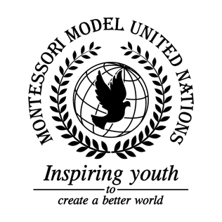

Resolution United Nations Human Rights Council/1.1

United Nations Human Rights Council
Co-sponsors: Republic of Albania, Antigua and Barbuda, Commonwealth of Australia, Belize, Dominican Republic, Republic of Estonia, Federal Democratic Republic of Ethiopia, Republic of Fiji, Republic of Iraq, Republic of Italy, Islamic republic of Mauritania, Principality of Monaco, Republic of Mozambique, Federal Republic of Nigeria, Democratic People’s Republic of Korea, Federal Republic of Somalia
Topic: The Safety of Journalists
The Committee,

Alarmed by the amount of journalists killed worldwide,
Aware of that journalists making a big impact on society,
Deeply concerned about journalist human rights,
Taking note that if this problem is not solved the UN will fail to meet SDG 10, reducing inequalities,
Confident that member states will support the protection of journalists;

- Encourages more protests for journalist safety in non-democratic countries;
- Further considers creating more safehouses/sanctuaries for journalists;
- Expresses its hope that journalists will have a hotline to call in peacekeepers;
- Recommends donations and fundraisers to raise awareness and teach citizens around the world about what is happening to journalists using the United Nations Safety of Journalists Fund (UNSJF);
- Supports Protective ID badges so that journalists can get into protected places around the world,
  - Use fake names;
- Further recommends making journalist’s workplaces safe by increasing security and preparing journalists;
- Considers buying kits including medicine, food, defensive equipment;
- Recommends that news companies educate their journalists about human rights, and also encourages self-defense training;
- Considers a treaty that promotes prisoner swaps.

