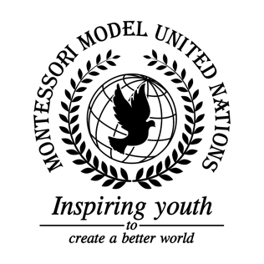

Resolution United Nations Human Rights Council/1.1

United Nations Human Rights Council
Co-sponsors: Republic of Armenia, Republic of Austria, Kingdom of Bahrain, Plurinational State of Bolivia, Republic of Bulgaria, Republic of Costa Rica, Republic of Finland, Georgia, Republic of Iceland, Republic of India, Japan, Republic of the Union of Myanmar, Republic of Namibia, Kingdom of the Netherlands, Sultanate of Oman, Republic of Rwanda, Republic of Seychelles, Republic of South Africa

Topic: The Safety of Journalists
The Committee,

Declaring that the protection of journalists is key to world peace,
Keeping in mind that 90% of journalists attacked are local,
Affirming the work done by The Committee to Protect Journalists, Reporters Without Borders, and many other NGOs,
Viewing with appreciation the work done by the UN,
Recalling Human Rights Council Resolution 39/6 and the UN Plan of Action on the Safety of Journalists, Having studied the history of journalist abuse, the Human Rights Council proposes the following solutions,
- Designates an organization that would identify and provide local journalists with access to international media entities;
- Proclaims a platform for journalists to share information with each other;
- Deplores countries to allow for freedom of the press and freedom of speech to develop media infrastructure;
- Draws the attention of the Human Rights Council and the public to the numerous challenges faced by journalists;
- Recommends prosecution governments who harm journalists,
- Requests that country leaders talk about this problem and its solutions among each other;
- Expresses its hope that in the future no journalist need fear for their life, and there by this the world will be made more safe and peaceful.

