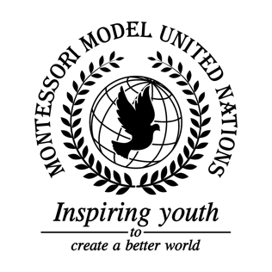

Resolution United Nations Human Rights Council/2.1

Human Rights Council
Co-sponsors: Republic of Azerbaijan, Kingdom of Belgium, Kingdom of Bhutan, Federative Republic of Brazil, People’s Republic of China, Republic of Cuba, Republic of El Salvador, Republic of France, Islamic Republic of the Gambia, Republic of Haiti, Hungary, Republic of Indonesia, Republic of Kenya, Lao People’s Democratic Republic, Libya, Grand Duchy of Luxembourg, the former Yugoslav Republic of Macedonia, Republic of the Marshall Islands, Kingdom of Morocco, Republic of Nicaragua, Republic of the Niger, Islamic Republic of Pakistan, State of Qatar, Republic of Sierra Leone, Republic of Slovenia, Solomon Islands, Saint Vincent and the Grenadines, Republic of the Sudan, Republic of Tajikistan, United Republic of Tanzania, Republic of Trinidad and Tobago, Republic of Tunisia, Republic of Uganda
Topic: Human Rights Situation in Yemen
The Committee,

Alarmed by the Yemenis’ violation of basic human rights,
Bearing in mind the risk that Yemenis citizens face every day,
Deeply conscious of the war’s cost that has been imposed on Yemen and their citizens,
Desiring everlasting peace for the nation of Yemen,

- Endorses the formation of a summit between the United States, Saudi Arabia, and Yemen for the purpose of a peaceful discussion regarding the blockade;
- Encourages the creation of a peacekeeping mission in Yemen for the purpose of protecting civilians, managing violence, and providing the general public with education, food, and clean water;
- Further recommends the creation of a certification program in order to help NGOs expedite relief in Yemen;
- Supports the use of social media for the purpose of raising awareness regarding the situation in Yemen;
- Calls upon small companies to provide jobs for the people in Yemen in exchange for food and water;
- Further invites countries to help provide resources for Yemen;
- Further invites the UN to Work together with the World Food Program and Red Cross in order to obtain food supplies and medical equipment for Yemen’s people.

