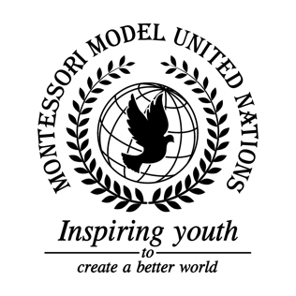

Resolution United Nations Human Rights Council/1.1

Human Rights Committee
Co-sponsors: Republic of Azerbaijan, Kingdom of Belgium, Kingdom of Bhutan, Federative Republic of Brazil, People’s Republic of China, Republic of Cuba, Republic of El Salvador, Republic of France, Islamic Republic of the Gambia, Republic of Haiti, Hungary, Republic of Indonesia, Republic of Kenya, Lao People’s Democratic Republic, Libya, Grand Duchy of Luxembourg, the former Yugoslav Republic of Macedonia, Republic of the Marshall Islands, Kingdom of Morocco, Republic of Nicaragua, Republic of the Niger, Islamic Republic of Pakistan, State of Qatar, Republic of Sierra Leone, Republic of Slovenia, Solomon Islands, Saint Vincent and the Grenadines, Republic of the Sudan, Republic of Tajikistan, United Republic of Tanzania, Republic of Trinidad and Tobago, Republic of Tunisia, Republic of Uganda
Topic: The Safety of Journalists
The Committee,

Fully alarmed by the ongoing crisis journalists face internationally such as murder and prosecution,
Recalling resolutions on the safety of journalists by UNHRC and the Security Council,
Fully believing that every journalist has a right to express and form their opinion truly,
Also recalling the adoption of sustainable development goals which all counties should reach by 2030,

- Calls upon the UN to hold summits and conferences to educate member-states on the reasons for press freedom;
- Encourages the review and revision of previous press freedom policies and freedom regulations;
- Requests the creation of peacekeeping programs including but not limited to education for local police as well as journalists;
- Endorses the use of safety indicators to determine the level of safety of countries for journalists;
- Strongly suggests raising awareness of the safety of journalists, especially through social media;
- Endorses the creation of more organizations such as Forbidden Stories, who publish the work of journalists who cannot publish their work themselves anonymously;
- Highly recommends the creation of a conference with the five most dangerous and the five least dangerous member-states to discuss how they can better improve the safety of journalists in their countries.

