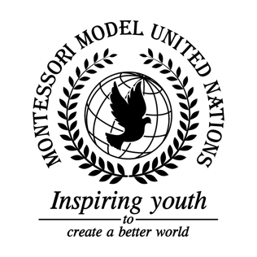

Resolution GA/3/2.1

General Assembly Third Committee
Co-sponsors: Republic of Angola, Federative Republic of Brazil, Republic of Cameroon, Canada, Commonwealth of Dominica, Republic of Ecuador, Republic of El Salvador, Islamic Republic of Mauritania, Republic of Moldova, Republic of Namibia, Federal Republic of Nigeria, Republic of Sierra Leone, Republic of Tajikistan.

Topic: Elimination of Racism, Racial Discrimination, Xenophobia in local communities
The Committee,

In accordance with sustainable development goal 10 reduced inequality,

Fully aware that education should be provided not only to students but also to teachers to prevent racism in schools,

Aware of the issue of racism and discrimination globally,

Alarmed by the fact that many immigrants, refugees, and migrants suffer from racism and discrimination ,

Recognizing that fostering an anti-racism education program in many countries in the world is essential to stop this issue,

Emphasizing the importance of the equitable participation of all, without any discrimination, in domestic as well as global decision-making,

Fully aware that there are different types of racism including covert racism and cyber racism,

Deeply disturbed that some countries have racism hidden in their culture,

Aware of the lack of education about racism and xenophobia,

Aware of countries discriminating against their native people,

Aware that there is very little (0.1%) genetic difference between people of any nation,

Disturbed by the fact that racist police brutality is still present,

Alarmed by huge racist campaigns,

- Approves the integration of immigrants in all economic and social levels;

- Calls upon countries to build help centers and hire experts to help and communicate with victims;

- Encourages all governments to reinforce laws and consequences against racism, xenophobia and all kinds of discrimination;

- Requests that governments should include and improve legislation so it clearly defines the right of speech, journalism, and social media to include true and factual information to help stop the spread of fake news on racism and xenophobia;

- Encourages all governments and NGOs to create international helplines for victims of all types of discrimination;

- Encourages all member states to avoid trade with countries that have not signed the Convention on the Elimination of all forms of Racial Discrimination or with countries that have signed it but have not yet enforced within its country;

- Encourages officials to receive specific training to detect and respond to hate crimes and to administer immigration detention producers in ways that respect human rights;

- Encourages authorities to build applications for information about different ethnic groups, races and all types of racial discrimination;

- Requests to ensure that everybody has access to good education without discrimination;

- Endorses to increase awareness on how racial bias impacts professional development;

- Encourages all schools around the world to mix different races from a young age so that there is no discrimination in the future;

- Calls upon Member States to take specific steps to ensure full and effective access to the justice system for all individuals, particularly those of African descent;

- Trusts that all the governments give the same rights to all of the population;

- Recommends countries the idea of creating a law of protection for victims and encourages funding investigations into racism and make sure all racists are prosecuted;

- Requests publicity campaigns or celebrities to appear in public spaces informing people the harm that racism and xenophobia causes and how wrong it is;

- Requests that social media companies spread awareness about racism and cyber racism;

- Calls upon all member states to follow article 1 of the Declaration on human rights, and teach it to the populations;

- Encourages NGOs to go around the countries and debate this issue with students.

