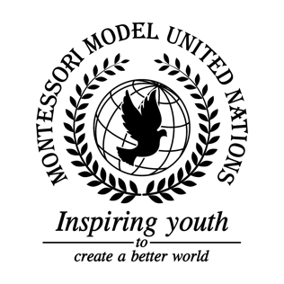

Resolution GA/3/2.1

General Assembly Third Committee
Co-sponsors: Islamic Republic of Afghanistan, People’s Democratic Republic of Algeria, Kingdom of Bahrain, People’s Republic of Bangladesh, Bosnia and Herzegovina, Republic of Botswana, Republic of Burundi, Republic of Cameroon, People’s Republic of China, Republic of Colombia, Republic of Croatia, Republic of Cyprus, Czech Republic, Dominican Republic, Republic of France, Grenada, Republic of Iceland
Topic: Elimination of Racism, Racial Discrimination, Xenophobia in local communities
The Committee,
Noting with regret that many people are discriminated against for race, caste, culture, gender, class, or religion,

Recognizing that people who are discriminated against don’t have adequate access to jobs, education and housing,

Affirming that many people have gotten discriminated against, and as of 2020, 101 teenagers were discriminated against in the US in only two weeks,

Acknowledging that many children are also victims of racial discrimination, and that this can result in children dropping out of school and being driven out of their communities,

Deeply disturbed by the number of victims of racial discrimination, xenophobia, and other hate crimes, given that there is less than 0.1% difference in people worldwide,

Bearing in mind that young African-American men were nine times more likely than other Americans to be killed by police officers,

Fully believing that every race, religion, gender, and culture should have equal rights,

Deeply disturbed by minority groups having rights taken away through unfair court judgments,

Alarmed by the number of racially discriminatory acts committed,

Deeply concerned by police being bribed to ignore racism, xenophobia, and related intolerant acts,

Takes into account the number of innocent people targeted,

Acknowledging that people have been discriminating against each other for a long time and it might take a while for people to understand that discrimination is not OK,

- Recommends each country to work with government officials and minority groups to create an anti-discrimination act;

- Encourages countries to make minority groups’ holidays as important as major groups’ holidays;

- Calls upon countries to create stronger laws to bring discriminators to justice;

- Affirms that the UN will provide funding for countries to enforce their anti-racism laws;

- Encourages countries to promote equality for people of every race, religion, class, ability, gender, and culture;

- Recommends that schools encourage children to understand and acknowledge one another in a positive way;

- Calls upon member states to improve health care for minority groups;

- Encourages all member states to create a free anti-discrimination education program for adults and children alike to educate them on discrimination and what to do about it;

- Endorses countries to use its taxes and other sources of fundraising to fund their anti-discrimination projects;

- Emphasizes that member states should educate citizens about the benefits of diversity;

- Recommends that countries create a hotline and official office for victims and witnesses of racial discrimination;

- Requests that countries recognize and participate in “Human Rights Days”;

- Reminds countries to promote gender equality, as stated in SDG goal #5;

- Further request security for large and/or cultural events to prevent acts of racism and xenophobia;

- Further request creating a safe house for those who are vulnerable or those who have already been victims of racial intolerances;

- Considers finding out which people are being affected and who is causing generally discriminatory acts;

- Suggests further development for police training to watch for acts of racism and discrimination;

- Suggests for the creation of an international police bribery and at-risk community watch group consisting of trained police from out of state;

- Calls upon member states to have protection programs for minority groups and displaced peoples.

