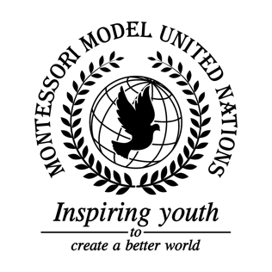

DRAFT Resolution Economic and Social Council/2.1

Economic and Social Council
Co-sponsors: Republic of Côte d’Ivoire, Republic of Finland, Republic of Guatemala, Republic of Hungary, Republic of Latvia, Republic of Nauru, Democratic People’s Republic of Korea, Republic of Tunisia
Topic: UN Forum on Forests
The Committee,

Viewing with appreciation the action of those member states who have instituted policy condemning deforestation

Guided by the understanding that the prevention of deforestation is critical to the prevention of climate change

Noting with regret that much unauthorized deforestation is done by farmers and developing nations out of necessity,

Taking into account that rainforests provide resources to developing nations,

Alarmed by the widespread destruction of rainforests,

- Requests that the UN can research how to control pests that are affecting forests and try to find alternatives for wood;

- Recommends improvements in the infrastructure:
  - Constructions that prevent mudslides and other natural phenomena that damage forests;

- Authorizes the UN to certify wood and encourage citizens of member states to only buy certified wood;

- Encourages member states to:
  - Support developing nations in transitions to environmentally sustainable economic systems:
  - Encourage banning bonfires and smoking in some specific forests;
  - Implement stronger punishments for those who let fires get out of control and motivate countries to set harsher laws to protect the environment and trees;
  - Establish security systems to prevent illegal actions on deforestation;
  - Implement stronger sanctions for violators;
  - Improve regulations regarding deforestation;
  - Help countries who are struggling with deforestation;
  - Use renewable energy (windpower, etc);
  - Establish recycling centers to decrease the amount of paper and other tree materials used;
    - Further invites governments to provide trash cans in forests so that people do not litter;
    - Encourages companies to use more eco-friendly packages and decrease their use of plastic;
    - Further invites recycling products, reducing the extraction of palm oil, encouraging buying certified wood products, and motivating member states to use all paper (reduce paper waste);

- Requests improving training for firefighters and enforcing surveillance in forests:
  - Capacitate firefighters to put out forest fires in a shorter amount of time;
  - Implement hoses in forests that are more susceptible to burning;

- Approves an agreement that emphasizes in forests and desertification in which countries state their goals and solutions:
  - Member states will have one year to present solutions and goals;

- Authorizes an educational program that:
- Encourages the education of sustainability for the future generations;
- Educates on the infrastructure issue;
- Provides education for:
    - Children about the importance of forests and ecosystems;
    - People about severity of deforestation and how species are losing their; habitats to encourage people to stop deforestation;
  - companies where to plant;
  - how to implement a sustainable agriculture;

- Requests economic sanctions for not following the program if signed and approved;

- Requests a Budget from:
  - UN fund, celebrities advertisement, NGOs support;
    - Ask NGOs and people to donate to help plant more trees;
  - Cooperative help between developing and developed countries;
  - Using a percentage of personnel and money from the UN to plant trees;

- Supports the revision of government's policies about the deforestation in order to have an improvement of the law and apply safer regulation:
  - Limitations of area use;
  - 1 tree planted for every person who cuts down a tree.

