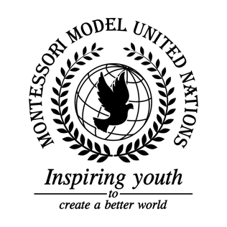

Resolution Economic and Social Council/1.1

Economic and Social Council
Co-sponsors: Bosnia and Herzegovina, Republic of the Congo, Republic of Côte d’Ivoire, Republic of El Salvador, Republic of Finland, Gabonese Republic, Republic of Guatemala, Republic of Honduras, Hungary, Republic of Latvia, Republic of Nauru, Democratic People’s Republic of Korea, Republic of Tunisia.
Topic: Advancement of Women

The Committee,

Noting with deep concern the continued practice of forced marriage (in clear violation of Article 16 of the Universal Declaration of Human Rights),

Alarmed by the fact that girls are not getting enough education,

Aware of the fact that women have lack of opportunity in jobs,

Deeply concerned of the number of women who suffer from domestic abuse,

Confident the international program addresses every problem regarding the advancement of women,

Noting with regret that women make less money for the same jobs as men,

Seeking to give women the opportunity of a proper education,

Believing that money is needed for this project,

- Decides upon the following long term solutions:
  - Encourages countries to give education on legal procedures: how to demand, get a lawyer and report abusive behaviors or rape;
  - Encourages teaching methods to destroy stereotypes, and end discrimination;
  - Further recommends projects to re-educate society to be respectful towards; women (eradicate sexism) and be an example for future generations;
  - Expresses its hope to get help from the UN budget, NGOs and volunteers for higher reach in education or poor zones (test of qualifications for volunteers and teachers);
  - Encourages women to be financially independent and open their own bank accounts;

- Also decides the following education solutions:
  - Further recommends member states take action to ensure equal access to a quality education;
  - Further requests that governments provide daycare and school for kids while their parents are at work;
  - Considers that technologies should be implemented to allow for good (MOD: Guatemala) education in different aspects: online school, classrooms, resources, have contributions from organizations and national help (management);
  - Encourages member states to add or improve sexual education in schools;
  - Recommends that economic sanctions are applied to countries who do not provide education to girls;
  - Endorses projects for education for children in rural areas;

- Further decides upon the following short term solutions:
  - Recommends schools to teach safe methods on money management and economic independence;
  - Encourages more women to work for police department;
  - Emphasizes the increase of jail time for sex offenders;
  - Encourages the elaboration and examination of wage gap injustices and seeking transparent statistics of payment for all genders;
  - Further recommends research to find out what obstacles cause women in each country to not want to go to work in order to support implementations;
  - Calls upon all governments to train employees who come across victims of physical or sexual violence to be able to manage such problems correctly;
  - Encourages governments to give women support systems and to speak about unfairness in the household and outside;
  - Calls upon member states to institute policy mandating paid maternity leave;
  - Further reminds member states that discrimination on the basis of gender is a human rights violation;

- Recognizes the following consequences:
  - Takes note of countries who agreed to the terms regarding corruption and budget management issues that slow the advancement of women
- Considers the following budget:
  - Recommends providing assistance to developing nations in their efforts regarding the advancement of women;
  - Encourages countries to accept help from the UN budget, Open Donations, NGOs and volunteers for a larger reach of education in developing nations.

